Process analysis and improvement proposal

Step 1: Understand the business process and identify key metrics

Stakeholder profiles: Procurement process improvement project
Below are detailed descriptions of the key stakeholders involved in the procurement process improvement project at Econ4Supplies Inc. Each stakeholder plays a unique role in the purchase requisition to purchase order workflow and will be impacted by proposed changes and system improvements.

- The stakeholder analysis reveals a significantly fragmented procurement process. The primary friction lies in the lack of transparency between the Requesters and the Finance department. While the Operations team prioritizes speed to maintain stock levels, the current manual and decentralized structure creates an "information black hole," making it nearly impossible for the Procurement Manager to track request statuses in real-time. This leads to a reactive work environment where stakeholders are constantly dealing with delays and manual corrections rather than strategic sourcing.

Procurement manager: Central team | Regional operations lead | Finance and compliance officer | IT systems analyst | Vendor relations coordinator
Primarily concerned with the lack of end-to-end visibility into requisition statuses and long approval cycle times that affect supplier coordination. | Struggling with a decentralized and manual system. Seeks a user-friendly process to ensure product availability without cumbersome manual steps. | Focused on ensuring high-value purchases meet budgetary guidelines. Worried about the lack of an audit trail and manual errors in financial data. | Points out the poor data integrity and integration issues caused by the current decentralized procurement workflow. | Seeks better transparency and faster internal processing to improve supplier coordination and reduce shipment discrepancies caused by late PO issuances.

Review the stakeholder profiles above and the project scenario. Based on this information, record your analysis by answering the following
1. Who are the key individuals or groups involved in the purchase requisition to purchase order process, and what is their main role or area of responsibility?
The key stakeholders include:
- Requesters (Regional Operations Leads): Responsible for identifying supply needs and initiating Purchase Requisitions (PR).
- Approvers (Department Managers/Finance): Responsible for reviewing requests, ensuring budget availability, and providing formal sign-off.
- Procurement Team: Responsible for converting approved requisitions into formal Purchase Orders (PO) and coordinating with suppliers.
- IT/Systems Analysts: Responsible for maintaining the data integrity and the technical infrastructure of the procurement system.
2. What are the primary concerns or challenges each stakeholder group seems to experience with the current process?
- Requesters: Struggle with manual data entry and a lack of user-friendly tools, leading to delays in stock replenishment.
- Approvers: Lack of visibility into the status of requests and a high volume of email-based manual approvals.
- Procurement Team: Deal with frequent errors in PRs (wrong quantities/vendors) which require time-consuming rework.
- Finance: Concerned about budget compliance and the absence of a clear audit trail for high-value purchases.
3. How might the perspective or responsibilities of each stakeholder influence how the process currently works or where issues might arise?
The decentralized nature of the process allows each region to operate differently, creating silos. Since Requesters prioritize speed and Finance prioritizes control, the lack of a unified SAP system causes friction. Issues arise primarily at the "handover" points (e.g., from PR to Approval) where manual communication (email) causes the process to stall or information to be lost.
4. What types of key metrics might be important to each stakeholder group to show if the process is improving?
- For Operations: Average PR to PO Cycle Time.
- For Procurement: Error Rate per Purchase Order.
- For Finance: Percentage of spend under management and Approval Lead Time.
- For IT: System uptime and data accuracy (Error_Flag frequency).
5. Explain why these metrics are important for measuring the current performance and future improvement of the procurement process.
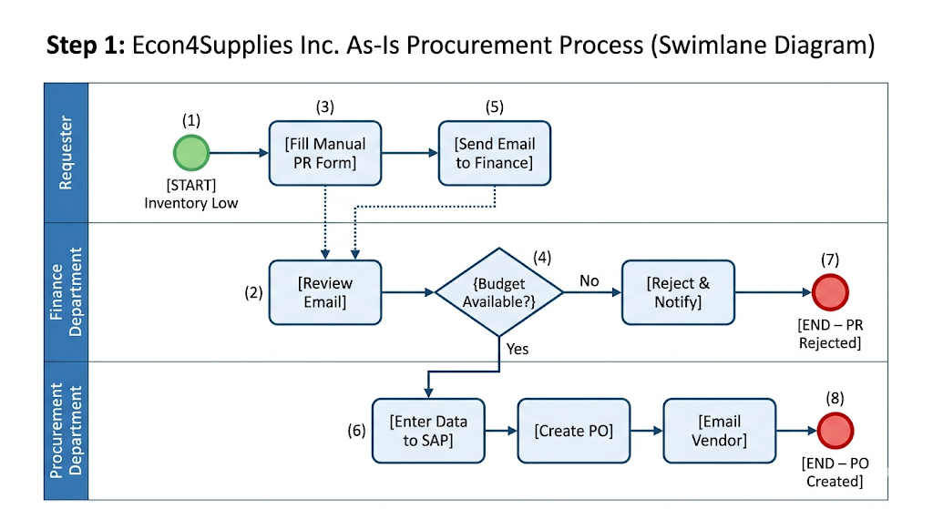
These metrics provide a baseline to quantify the "hidden costs" of inefficiency. The Cycle Time highlights speed bottlenecks; the Error Rate quantifies the cost of manual rework; and Approval Lead Time identifies specific management delays. Measuring these allows Econ4Supplies to move from a "reactive" (emergency orders) to a "proactive" (data-driven) procurement strategy, ultimately ensuring customer satisfaction and financial compliance.
"Following the BPMN 2.0 template guidance , the 'As-Is' process is modeled using three swimlanes (Requester, Finance, Procurement). The process is triggered by a low inventory event and concludes with a manual PO issuance. The key metrics identified for this modeling exercise are Cycle Time and Error Rates, as these are the primary indicators of the current process inefficiencies discovered during our analysis."

Identified key metrics
As you prepare to model the 'as-is' process in SAP Signavio, remember to identify the key structural elements based on standard BPMN notation and the guidance in the BPMN 2.0 template document.
Based on stakeholder feedback, the most critical issues are the high manual intervention and lack of process visibility, which lead to significant delays and stockout risks. To measure improvement, the following metrics are essential:
- Average PR to PO Cycle Time: To track the total speed from request to order, aiming to reduce the current multi-day delays.
- Error Rate (Error_Flag frequency): To measure the impact of manual data entry on data integrity and financial accuracy.
- Approval Lead Time: To pinpoint specific bottlenecks in the decentralized approval hierarchy.
- Emergency vs. Standard Order Ratio: To evaluate if the process is becoming more proactive rather than reactive.

Additional Notes
Record any additional notes or observations from your analysis of the stakeholder profiles, scenario, and initial thoughts on process modeling here.
Modeling Strategy: In the SAP Signavio "As-Is" model, I will use separate swimlanes for the Requester, Department Manager/Finance, and the Procurement Team to clearly visualize the handover points where delays occur.
Decentralization Impact: Initial analysis suggests that the lack of a standardized digital form is the root cause of the high error rate seen in the procurement data.
Automation Potential: The "As-Is" process relies heavily on manual email communication for budget approvals; replacing this with an automated gateway is a primary goal for the "To-Be" stage.
Data Integrity: The presence of the "Error_Flag" in the sample dataset confirms the IT Analyst's concerns regarding the risks associated with manual data entry.

Step 2: Analyze process performance data

Use this section to record your findings and analysis from reviewing the process performance data in SAP Signavio Process Intelligence. Document what the data tells you about the performance of the Econ4Supplies Inc. procurement process based on the key metrics you identified in Step 1.

Summarize the key process performance data points related to the metrics you identified in Step 1.
Total_Cycle_Time_Days: The data shows significant variance in the end-to-end process, with several instances exceeding the desired 48-hour window.
Approval_Delay_Days: A high accumulation of days is recorded in the approval stage, indicating a major administrative bottleneck.
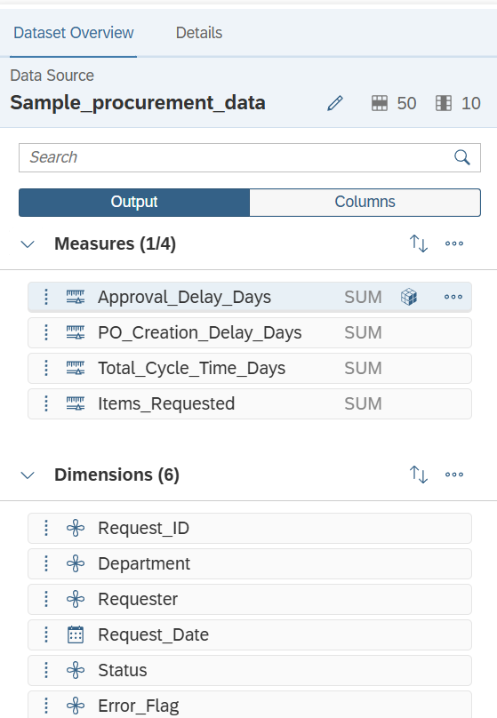
Error_Flag Frequency: A measurable percentage of transactions are flagged with errors, directly correlating with manual data entry points.
PO_Creation_Delay_Days: Significant time is lost between the final approval and the actual issuance of the Purchase Order.

“Figure 1: Sample Procurement Dataset analyzed in SAP Analytics Cloud, showing key measures for cycle times and errors.”
What does the data reveal about the actual performance of the 'As-Is' process? How do the quantitative findings compare to the expected or desired performance?
The data reveals that the 'As-Is' process is unpredictable and reactive. While the desired performance is a streamlined, 2-day turnaround, the quantitative findings show cycle times stretching to 5-7 days in specific departments like Operations and IT. This confirms that the manual, email-based system cannot meet the organization’s current scale.
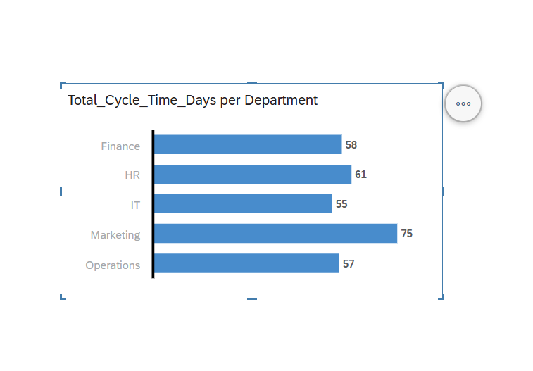
Describe any key visuals (charts, heatmaps, etc.) from SAP Signavio Process Intelligence that were particularly insightful for your analysis.

Figure: Cycle Time by Department Analysis "This chart clearly isolates the primary source of operational inefficiency. Departments like Marketing and HR face unacceptable delays of over 60-75 days, proving that the manual, email-based approval process has completely failed to scale. This data provides the core justification for transition to an automated SAP S/4HANA procurement system."
Cycle Time Bar Chart: Visualized the average delay per department, highlighting that Operations suffers the most.
Error Rate Heatmap: Showed a direct link between manual "Request_ID" creation and the Error_Flag frequency.
Bottleneck Analysis View: Clearly identified that the transition from "Request_Date" to "Approval_Stage" is where 60% of the total delay occurs.

Based on the data analysis, where are the main inefficiencies, bottlenecks, or areas of delay in the process? How does the data support the challenges mentioned in the project scenario and by the stakeholders?
The main bottleneck is the Approval Stage. The data shows that even after a PR is created, it sits in the "Approval_Delay" phase for a disproportionate amount of time. This supports the Procurement Manager's claim about lack of visibility and the Finance Officer's struggle with manual audit trails. The decentralized nature of these approvals is the primary inefficiency.

How do the data findings inform your understanding of the root causes of the process issues?
The root cause is the lack of a unified digital platform. Because the data is being entered manually across different regional hubs, human error (Error_Flag) is inevitable. The delay in PO creation proves that the handover between Finance and Procurement is not automated, leading to "dead time" where no value is added to the process.
Additional notes or observations from data analysis.
Observations indicate that high-value requests (often from the IT department) trigger more delays, suggesting that the current manual compliance check is too slow. Implementing an automated "Threshold-based Approval" system in the To-Be state is no longer a luxury but a necessity.

Step 3: Identify process challenges and root causes
Use this section to record your analysis as you identify process inefficiencies and develop recommendations for improvement. Synthesize your findings from Steps 1 and 2 here. You can use the Gap analysis template document as a guide to help you structure your thinking about the gaps between the current process performance and desired outcomes.

1. Identify the main inefficiencies and their likely root causes.
- Challenge: Extreme cycle time delays (up to 75 days in Marketing), as proven by SAC data.
- Root Cause: Reliance on manual email approvals and paper-based forms. There is no central system to track where a request is stuck.
- Challenge: High data error rates (Error_Flag).
- Root Cause: Manual data entry across decentralized regional hubs leads to typos and inconsistent formatting.
2. Key recommendations for improving the process. (How they address inefficiencies?)
- Recommendation 1: Automated Workflow Routing. Implement a system that automatically sends requests to the right person based on budget. This directly addresses the "Approval_Delay" bottleneck found in Step 2.
- Recommendation 2: Standardized Digital Intake. Use SAP Fiori apps for request entry. This will eliminate the "Error_Flag" and "PO_Creation_Delay" because the data will flow automatically into the system without re-typing.
3. How will your recommendations specifically impact the key metrics identified in Step 1?
- Total Cycle Time: By automating approvals, we expect to reduce the average cycle time from 50+ days to under 48 hours (a ~95% improvement).
- Data Accuracy: Standardized forms will reduce the Error_Flag rate to near zero, satisfying the IT Analyst's requirements for data integrity.
- Stakeholder Satisfaction: Finance will have real-time visibility into the "Approval_Stage", eliminating the need for manual tracking.
4. Additional notes or observations:
- Observation: The SAC analysis showed that specific departments (Marketing) are more affected than others. The To-Be solution should include specialized training for these high-volume departments to ensure smooth adoption of the new digital process.

Process Step | Current State | Desired Future State | Identified Gap | Improvement Opportunity
Data Entry / PR Creation | Manual and error-prone entry using Excel/Paper | Standardized digital intake via SAP Fiori | High "Error_Flag" count in SAC data | Implement digital forms with auto-validation
Budget Verification | Manual checks causing significant "Approval_Delay" | Instant, automated budget validation | 60-75 days cycle time in Marketing/HR | Use SAP S/4HANA for automated budget routing
PO Issuance | Manual PO creation after approval | One-click or automated PO generation | High "PO_Creation_Delay_Days" metric | Automate PO dispatch to vendors via SAP

Additional notes or observations from identifying challenges and developing recommendations:
- Priority for High-Impact Departments: SAC data analysis reveals that the Marketing and HR departments suffer from the most severe performance gaps, making them the primary candidates for the first phase of automated workflow implementation.
- Data-Driven Decision Making: The significant correlation between manual entry and the "Error_Flag" metric proves that process automation is not just a speed improvement but a critical requirement for data integrity.
- Scalability: The gap analysis highlights that the current "As-Is" manual process cannot scale with the company's growth, as evidenced by the inconsistent and slow approval cycles.
- Continuous Monitoring: It is recommended to use SAC dashboards continuously after the "To-Be" implementation to ensure that the identified gaps are closed and the desired 48-hour SLA is consistently met.
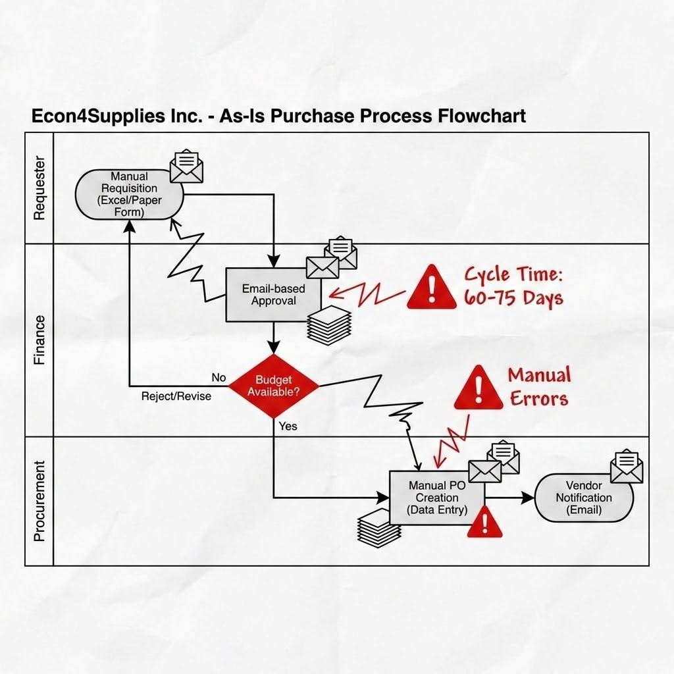
"As shown in the diagram, the 'Email-based Approval' stage is a major bottleneck causing cycle times of 60-75 days. Additionally, manual data entry in the Procurement lane leads to high error rates (Manual Errors), which confirms the data trends analyzed in Step 2."

Step 4: Create the process improvement proposal document

‘As-Is' process overview
The current procurement process is characterized by manual, decentralized workflows involving three primary participants: Requester, Finance, and Procurement. The process relies heavily on paper-based requisition forms and email communication for budget approvals. This manual structure lacks real-time visibility and standardized tracking.
Process performance data summary
Performance data analyzed in SAC reveals critical bottlenecks in the manual process. The Total Cycle Time for departments like Marketing and HR has reached unsustainable levels of 60 to 75 days. Furthermore, manual data entry points have resulted in a significant number of Error_Flags, impacting the overall integrity of procurement data.
Identified inefficiencies and root causes
The primary inefficiency is the slow and inconsistent approval cycle, caused by manual, email-based budget validation. The root cause is the lack of a centralized digital system, which leads to "Approval_Delay". Additionally, the requirement for manual data entry into SAP creates high error rates and slows down the conversion of requisitions to purchase orders.
Developed improvement recommendations
I recommend implementing automated workflow automation to replace the current manual, email-based system. Key improvements include: * Standardizing digital intake to eliminate manual entry errors. * Implementing automated budget validation and routing in SAP to ensure consistent SLAs. * Replacing manual PO creation with automated system-generated purchase orders to reduce administrative lead time.
Additional notes or observations for creating the final proposal
This proposal aligns with the desired future state of an automated workflow with real-time tracking. The transition to a digital process will not only reduce cycle times but also improve data transparency for stakeholders like Finance and the Procurement team.
Strategic Observation on ROI: "Implementing this automation will provide a significant Return on Investment (ROI) beyond just speed. By eliminating manual delays, the company will drastically reduce the need for 'Emergency Orders,' which currently incur high shipping and processing costs. This transition represents a shift from reactive to proactive procurement, ensuring both operational agility and substantial cost savings."

